|  |  |
| --- | --- |
|  | 1.Hoisting  2.closure  3.Prototype  4.Call,apply,bind method  5.Spread operator  6.Var,let,constant  7.Array Methods(find,filter,map,reduce) |
| Reference | https://www.youtube.com/playlist?list=PL7JmcZV0UQtUc8hMA29UqHextvsr3y4XG |

Clear concept:

***Js 2 phase e kaaj kore memory allocation thn code execution***

***1.var declare korar shthe shthe memory allocation pay but Jodi decelare er ager line gulate call kori variable k default bhabe undefined value show korbe***

***2.eke hoisting er maddhome declare er age var k call kore taar value pawa jay***

***Conditions:function er bhitor var k call korte hbe thn func call korte hbe***

***(only normal func r var hoisting support kore)***

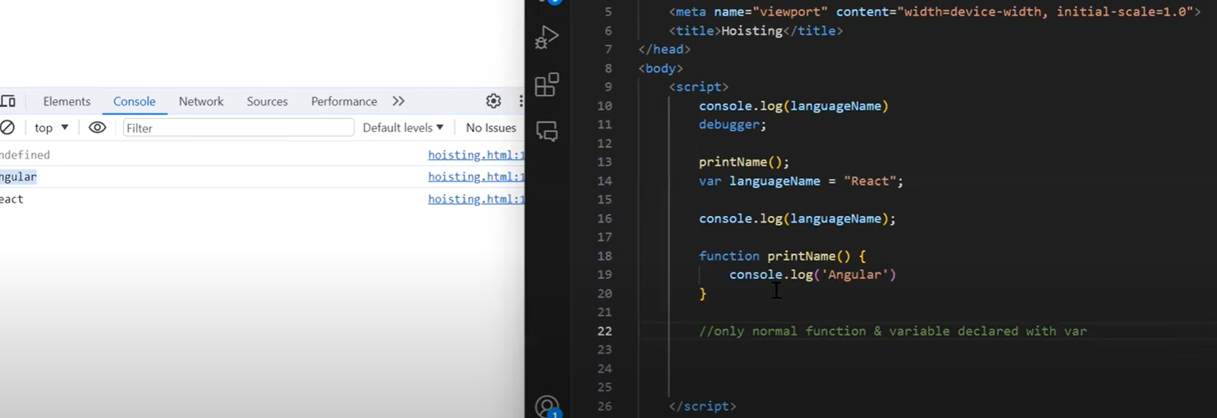

Var er bhitor func or arrow func use kore hoisting hbe na

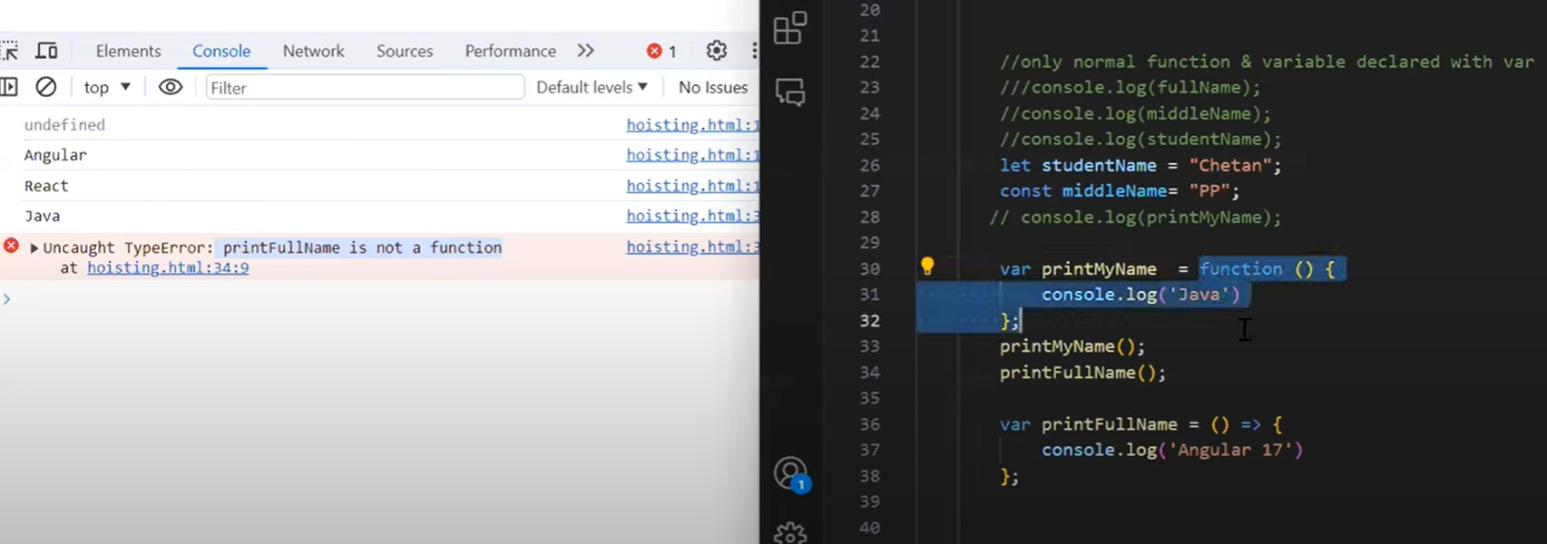

Coding snippets:

a.

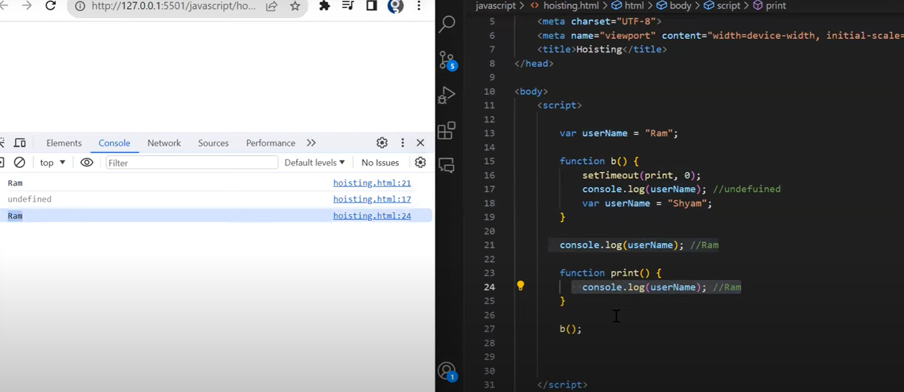

b.jeita outer or public var r call sheta age execute hobe tai anguler age run hoise

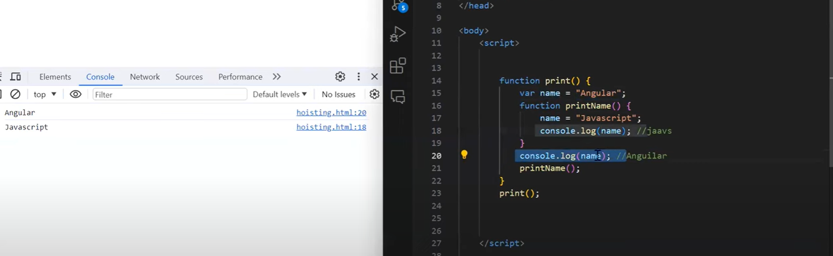

c.bhitorer func e var er kono value dewa hoy nai tai undefined value default gese

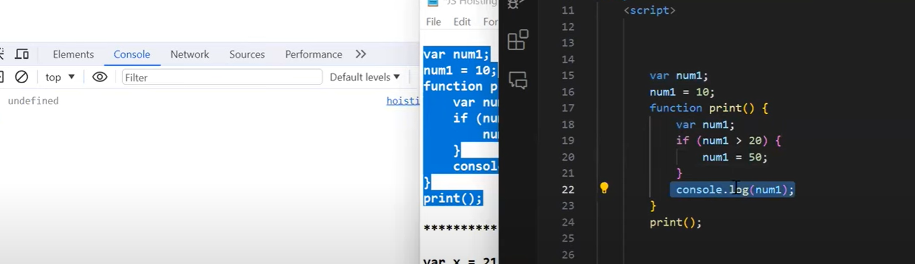

d.var initialization er agei call kortesi func eo tai undefined e ashbe

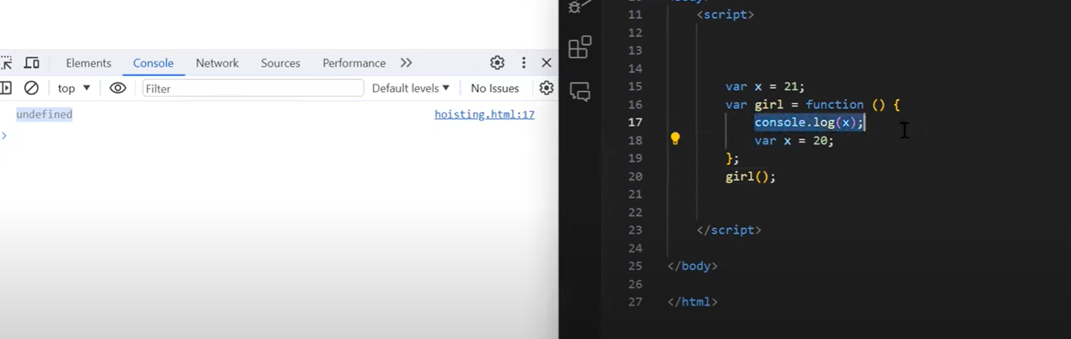

Func e just call korbo var public thakbe

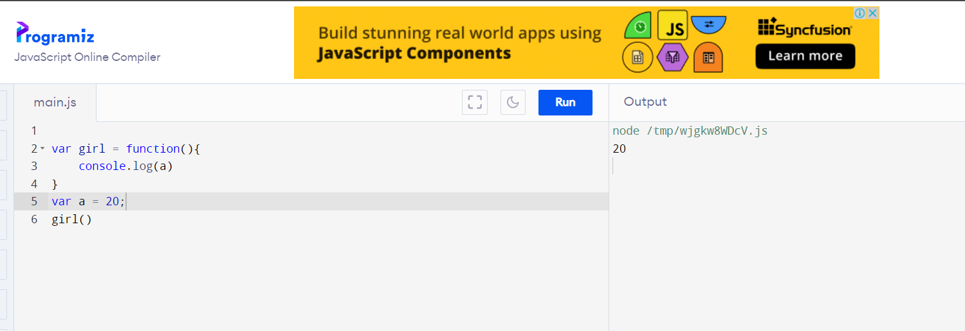

e.ekhane 1st ta global var hoye jay r value pay shesh er ta…r ager ta default value pay undefined (valueless)

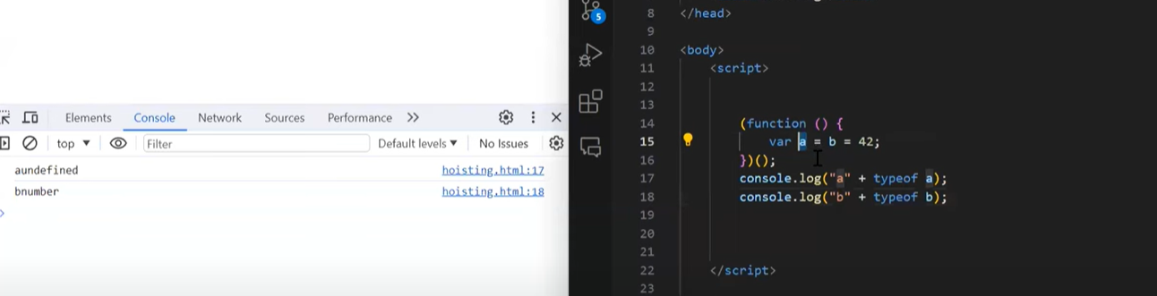

2.Closure

Outer er var gula amra inner func e access korte parbo etake bole closure..ei concept ei global var accessible shob func er jonnei

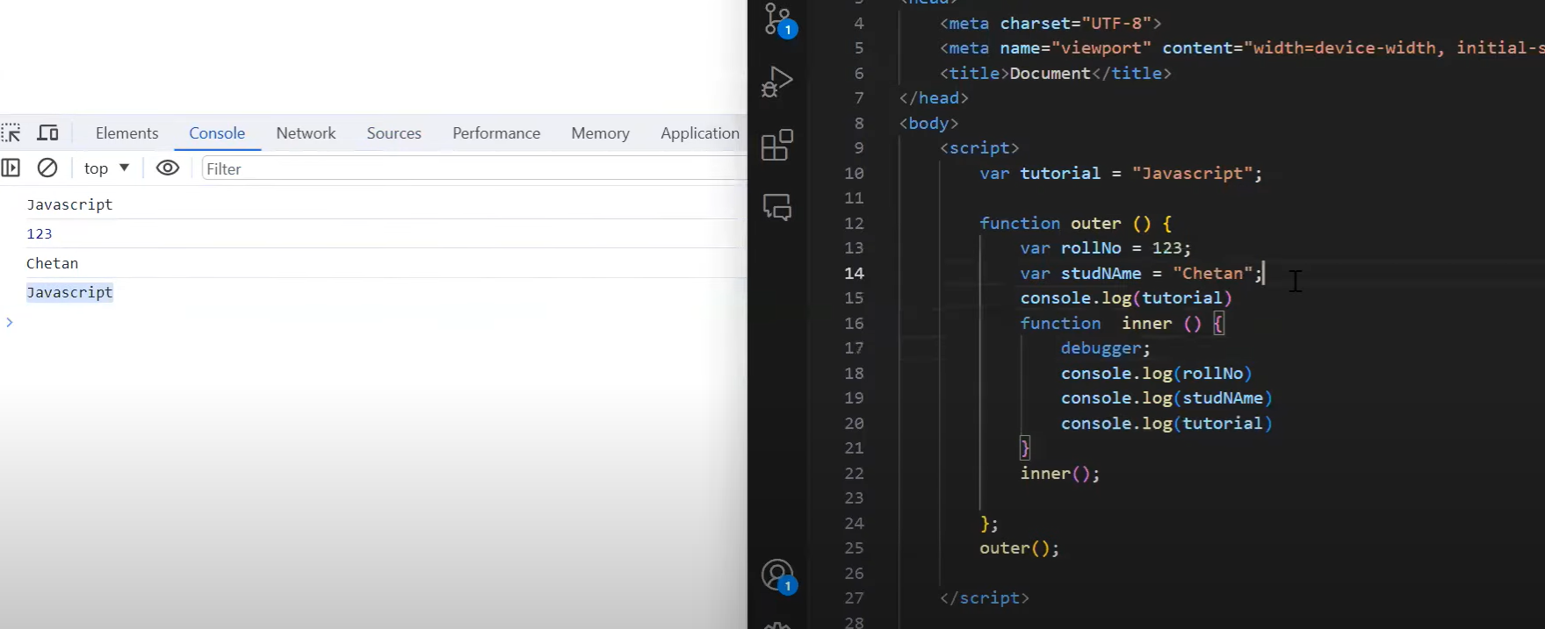

a.inner2 func has 2 closure outer and inner

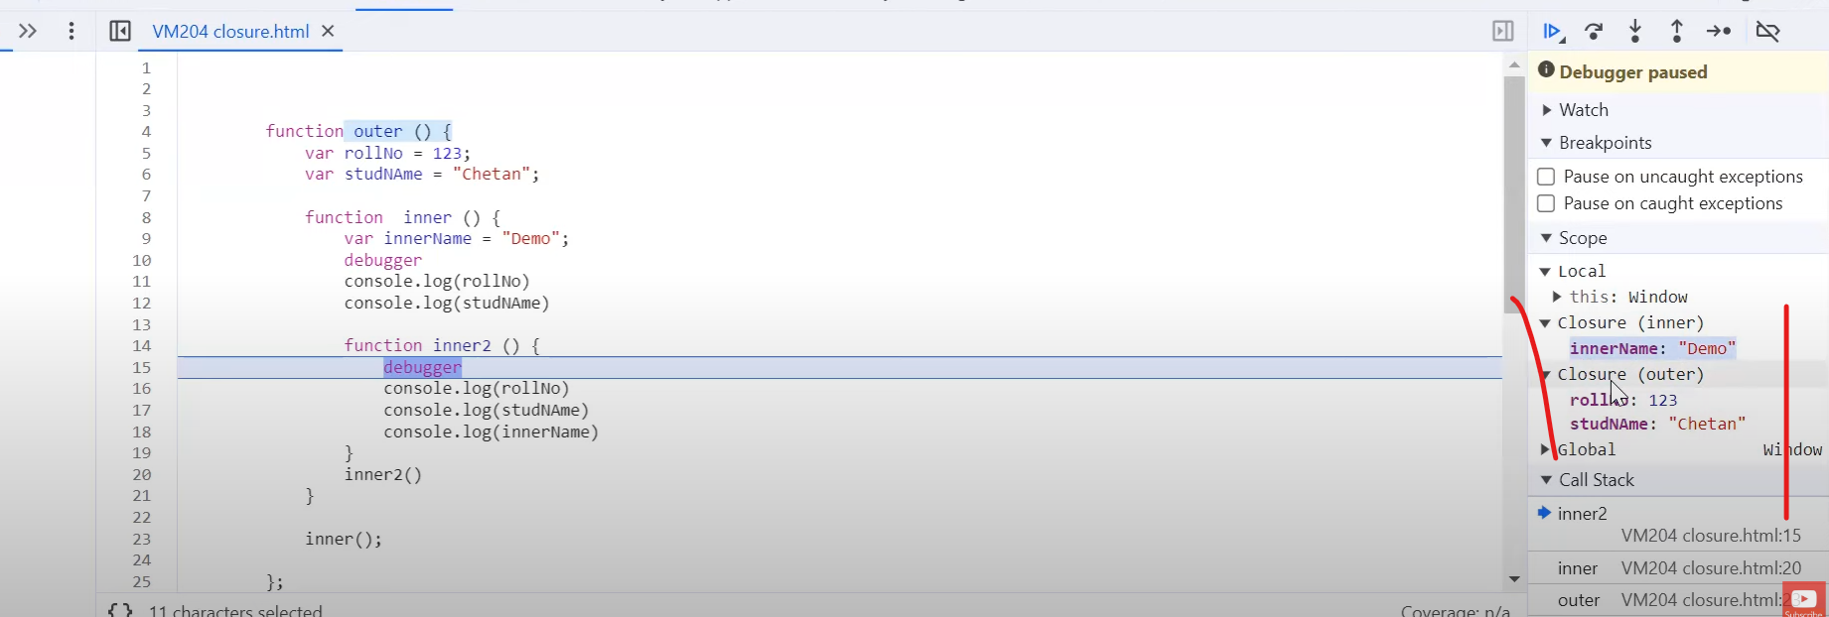

b.setTimeoput assync js func Jodi for loop er bhitor use kori tahole last number theke 1 beshi dekhabe baar baar loop chola porjonto but Jodi amra let use kore Jodi settimeout use kori prblm thakbe na..for e amra use korte parbo extra line likhe

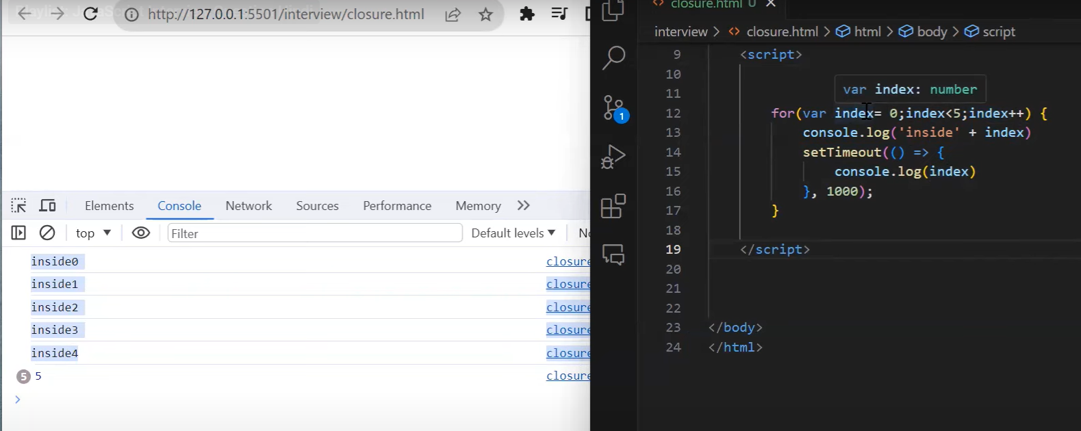

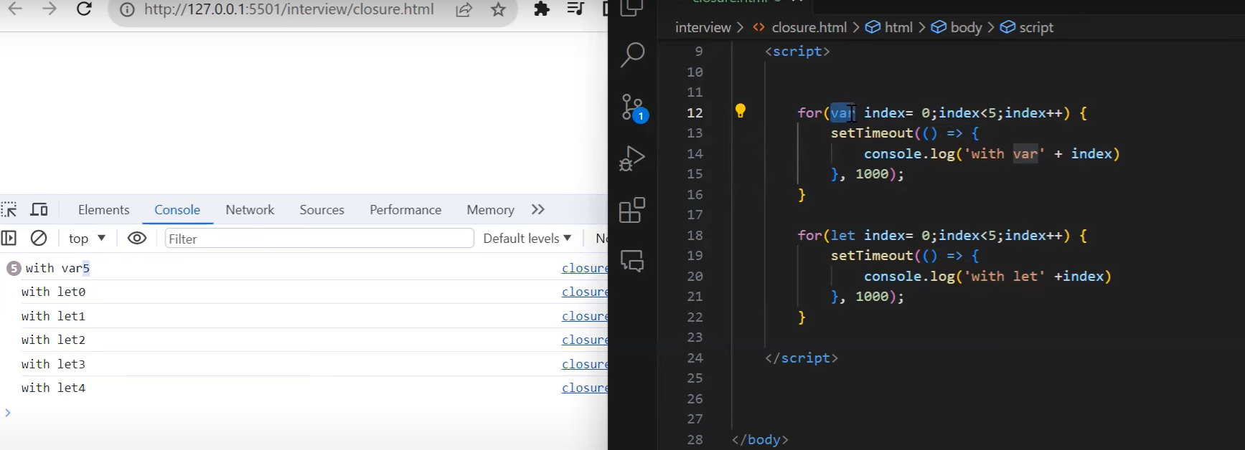

c.var er default behaviour func r global e..ekhane func er bhitor var naitahole globally access kora jabe ..but let loop er baire use kora jabena(let blockscope)

ex: 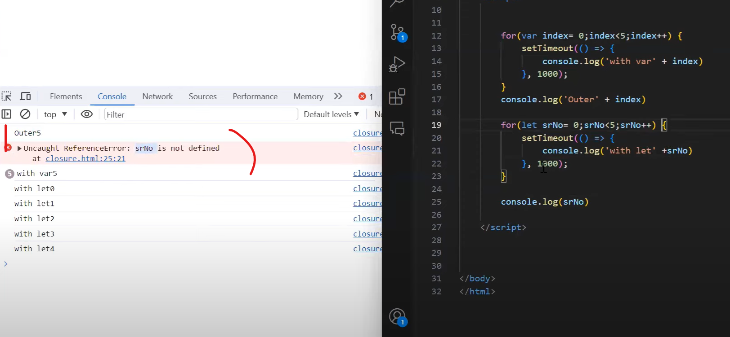

d.Jehetu for loop e instance ektai thake change hoite thake just value..amra loop er bhitor parameter wala function use korbo(num) ete settimeout er jonno alada alada instance banabe ei loop and func call korbo index er value hishebe jate shb gula instance dekhay

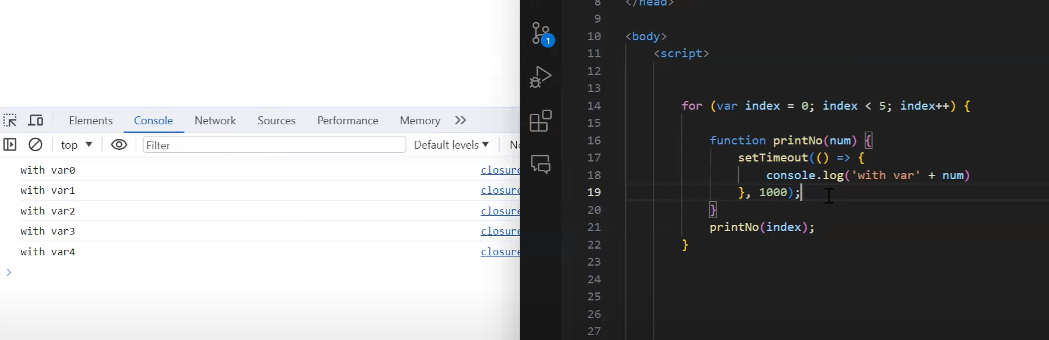

**3.Prototype**

**Different type of data declare kore shei var er por dot dile method r properties suggest hoy oi data typer jonno etai prototype kore rakhse js engine e ..eigula js engine object akre assign kore rakhse**

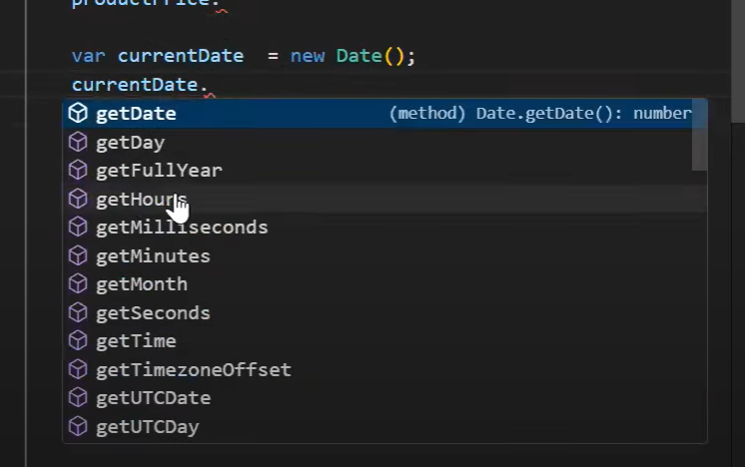 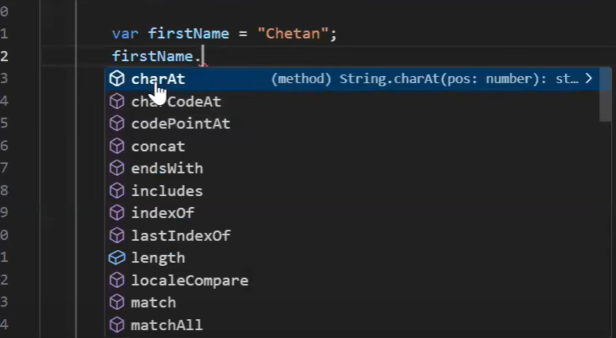 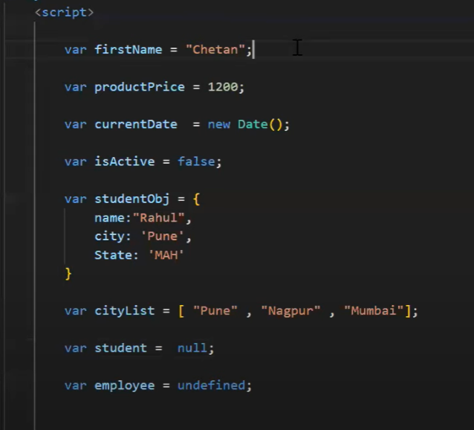

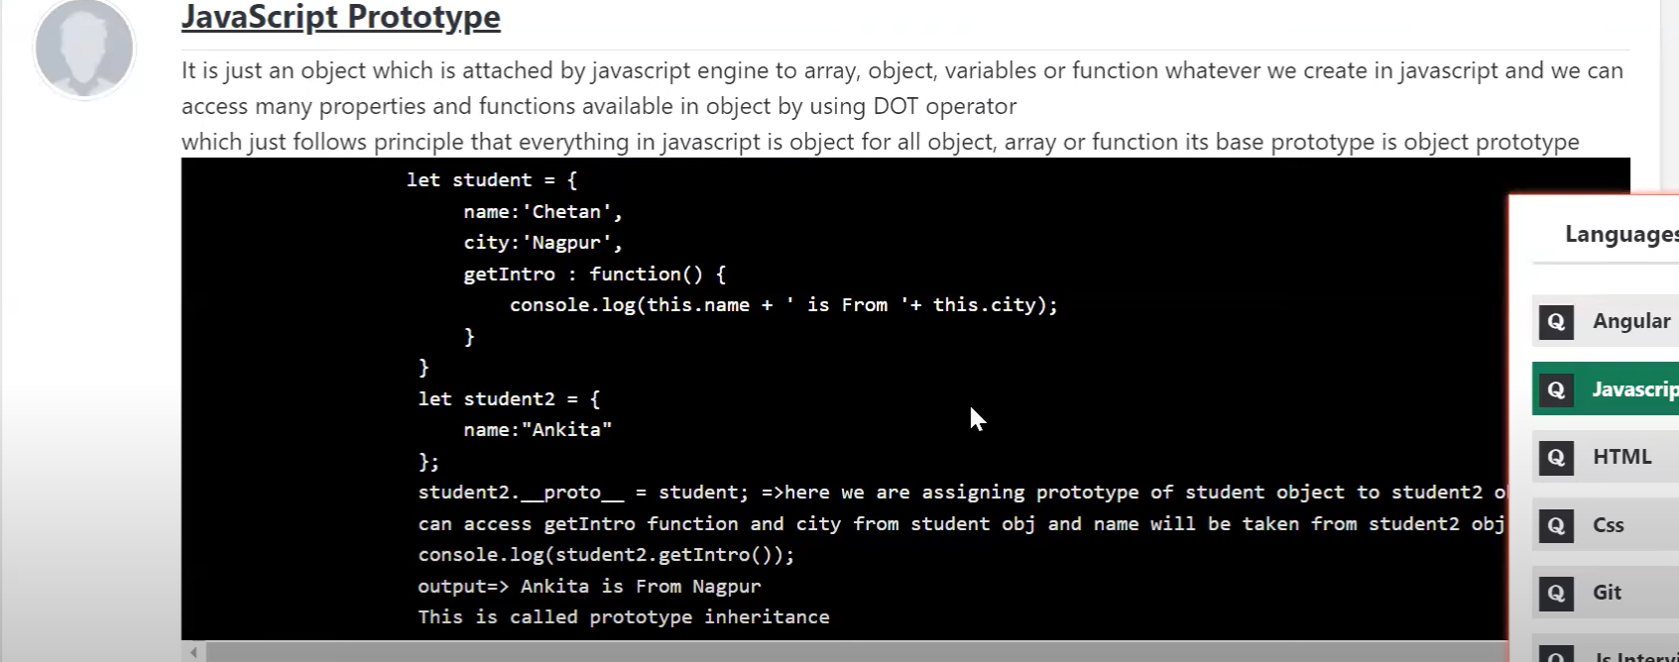

**Everything in js is an object…**

**.__proto__ dile ki type er data show kore shesh porjonto gele dekha jay string o object akare assigned js e**

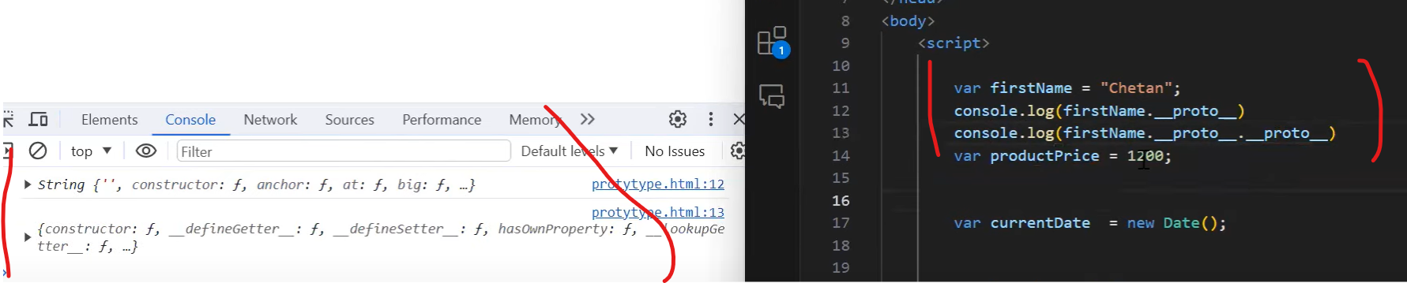

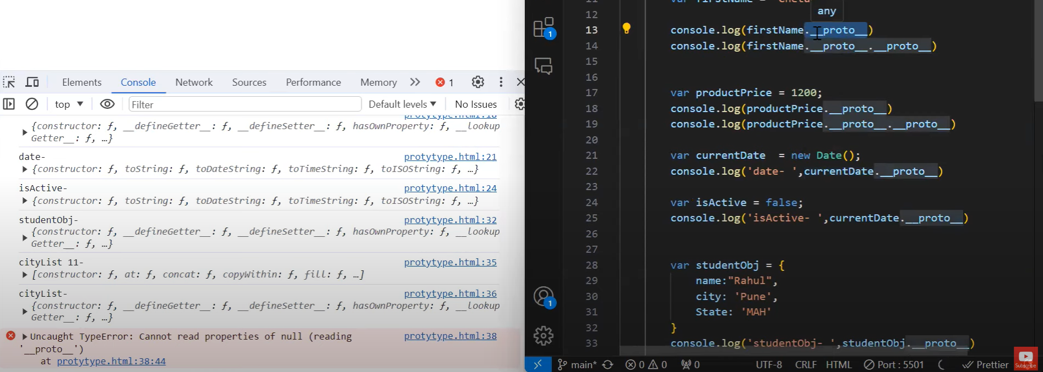

a.object er bhitor func create korar upay

i.properties er value er jaygay func likhbo

ii.access korte this.var use korbo

ii.func call korte objname.func()

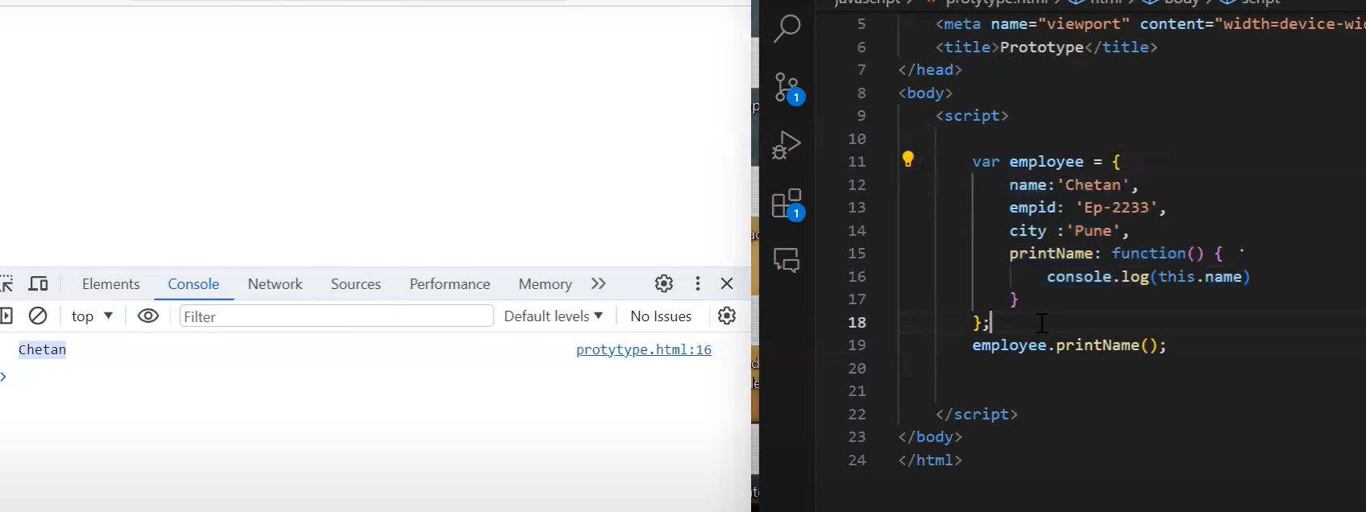

b.proto use kore onno obj e func access kora jabe func baar baar na likhe

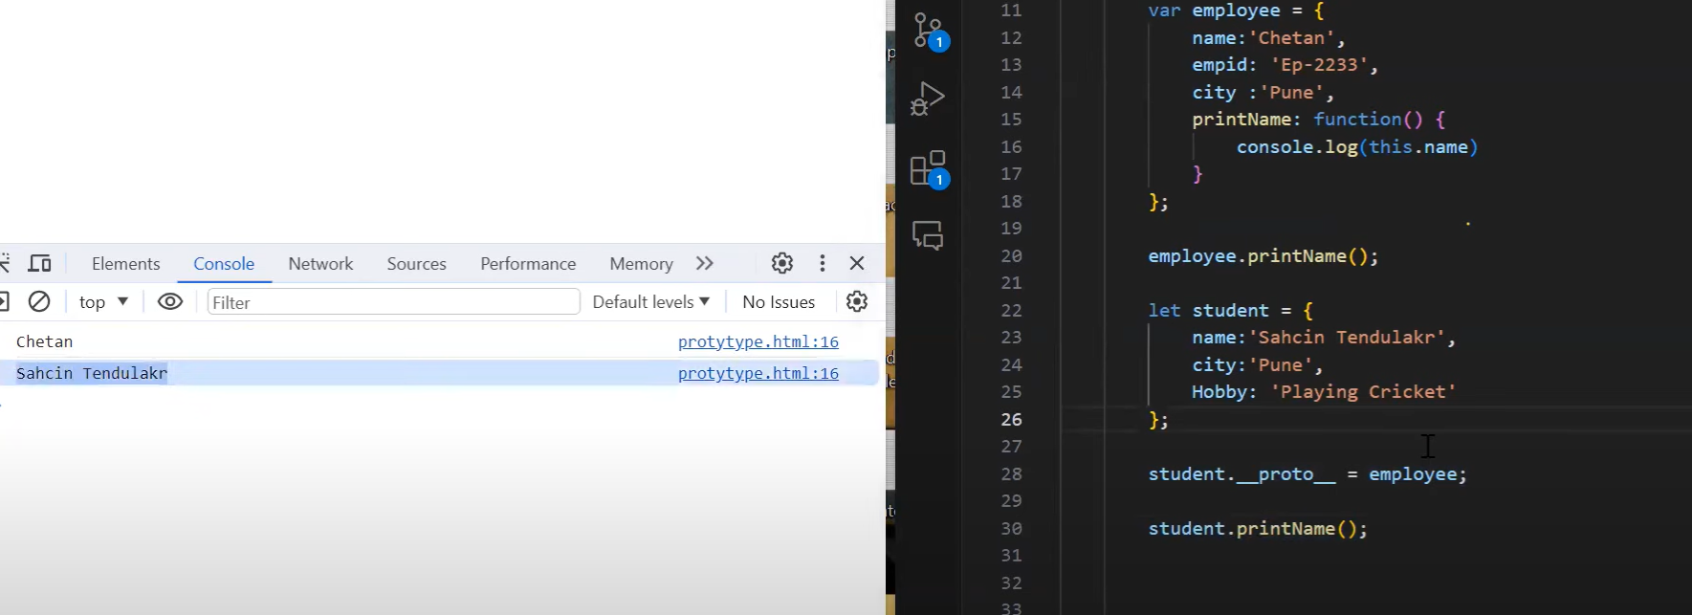

Employeeobj erjoto func thakbe student obj pabe tai printname() func kaaj kortese student e

**4.Call,apply,bind method**

**Call**

**a.**

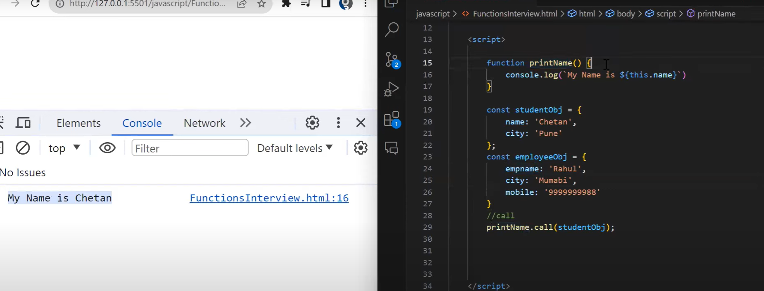

**i.printname func e console.log korbo but var e this. Use korbo karon obj theke access korbo**

**ii.koyekta obj declare kore properties diboe**

**iii.funcname.call.(objname) –this is a reusable func**

**ebhabe ekta func call er maddhome bohu obj e use korte parbo**

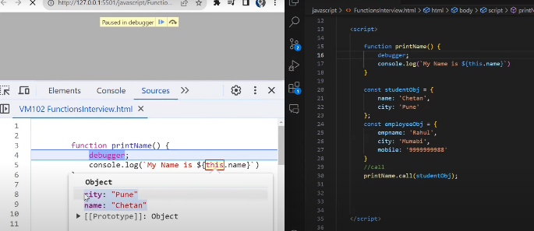**studentobj er jonno pura properties show kortese**

**call,applu,bind khali normal func e kaaj korbe..\*\*\***

b.Function e parameter use kore

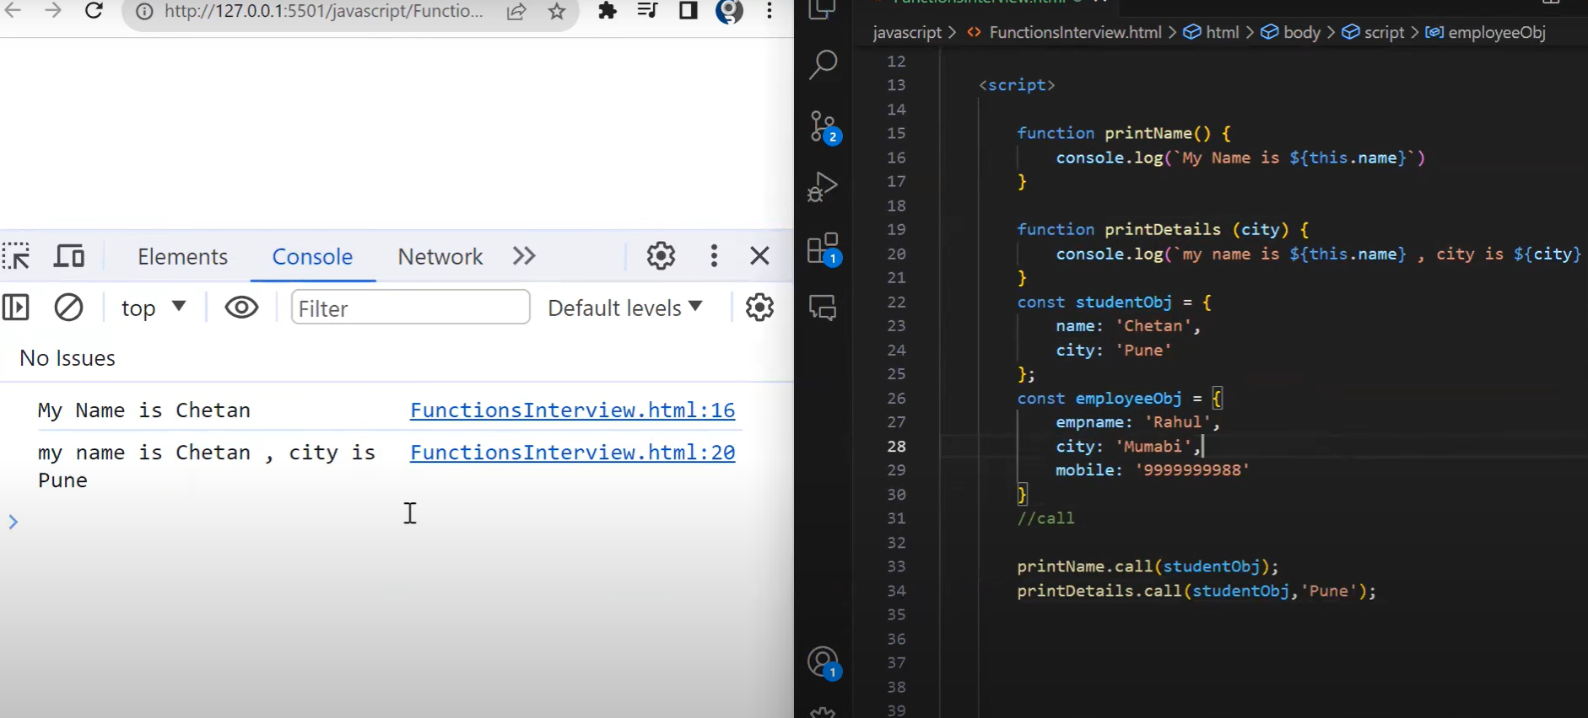

i.func (city) param dewa

ii.params console e use kora

iii.call kore param er value dewa ,’pune’..same bhabe 2 ta params diyeokorte parbo

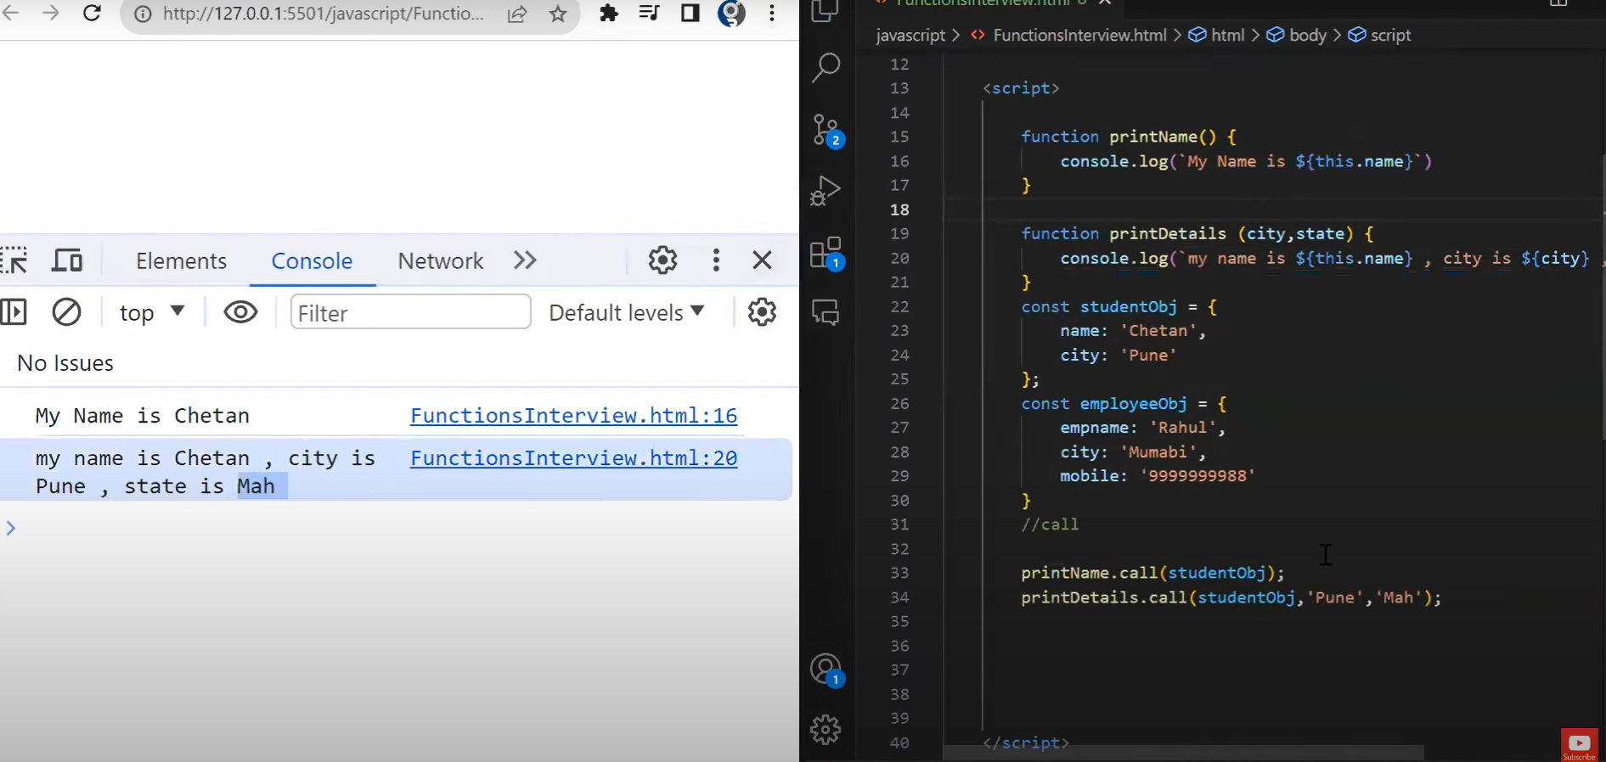

**Apply**

Params call Jodi array er moddhe korte chai call diye amdr 1st param er value pabe but shesh er gula pabe na undefined dekhabe ei prblm solve kore apply

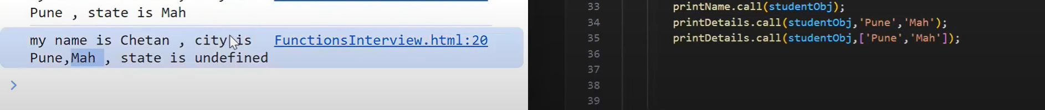

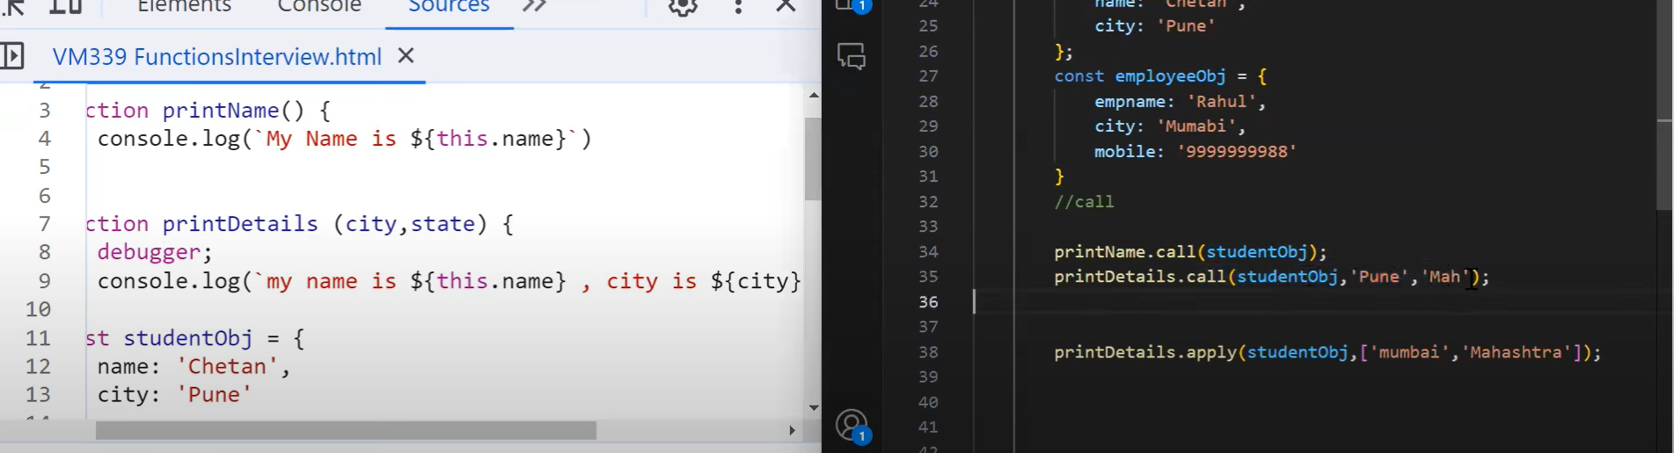

**Bind**

Var =func+obj

Ekta variable e func r object k bind kore future e use korar jonno banana hoy

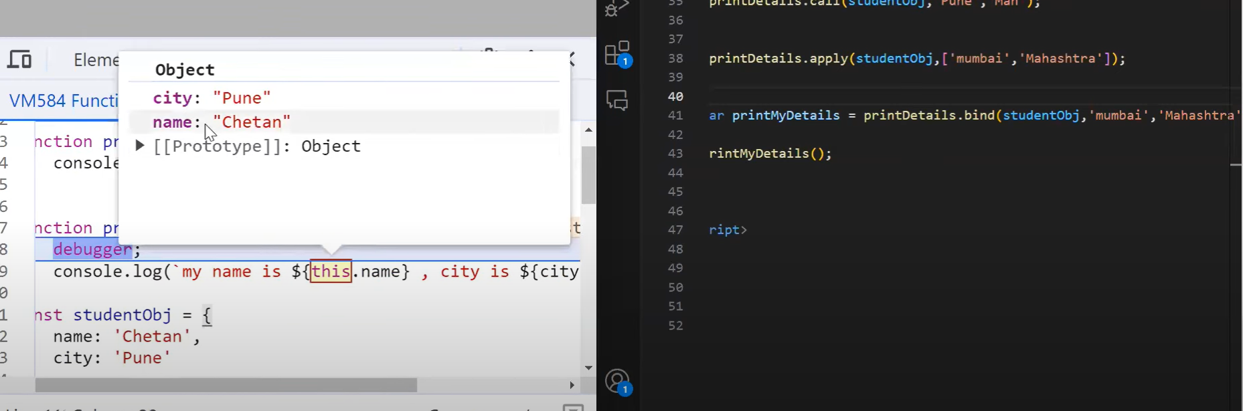

**Apply bade array diye params er value dewa jayna..\*\***

**5.Spread operator**

**Purpose (syntax 3dots)**

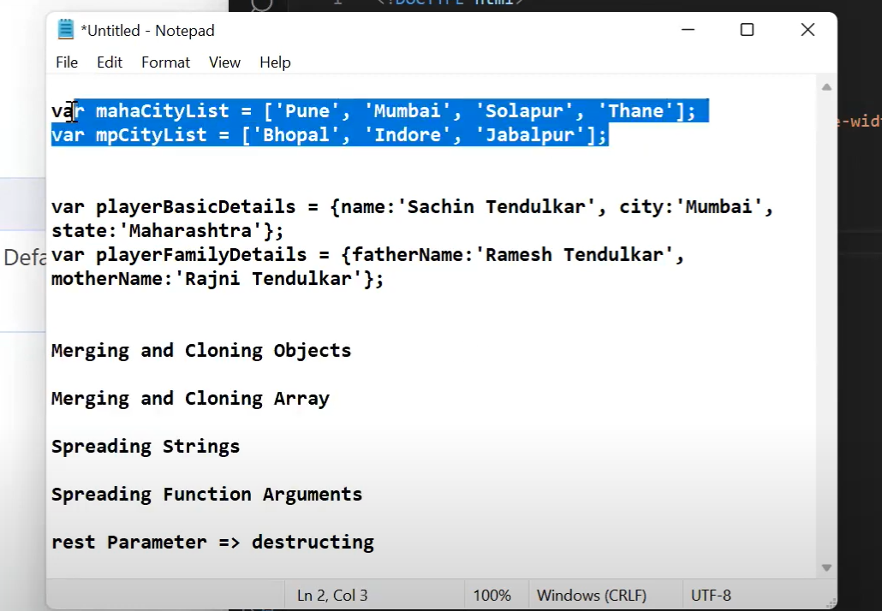

**1.Merging and cloning arrays**

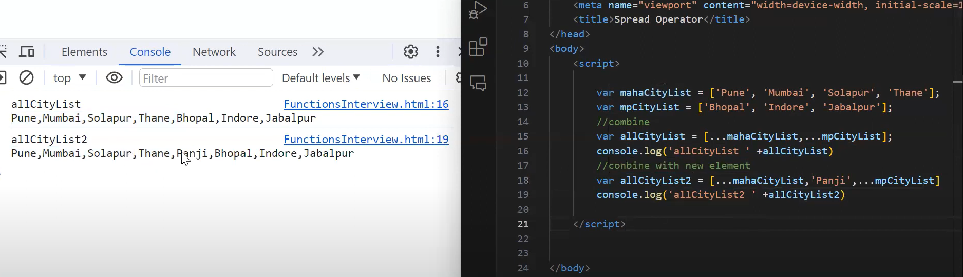

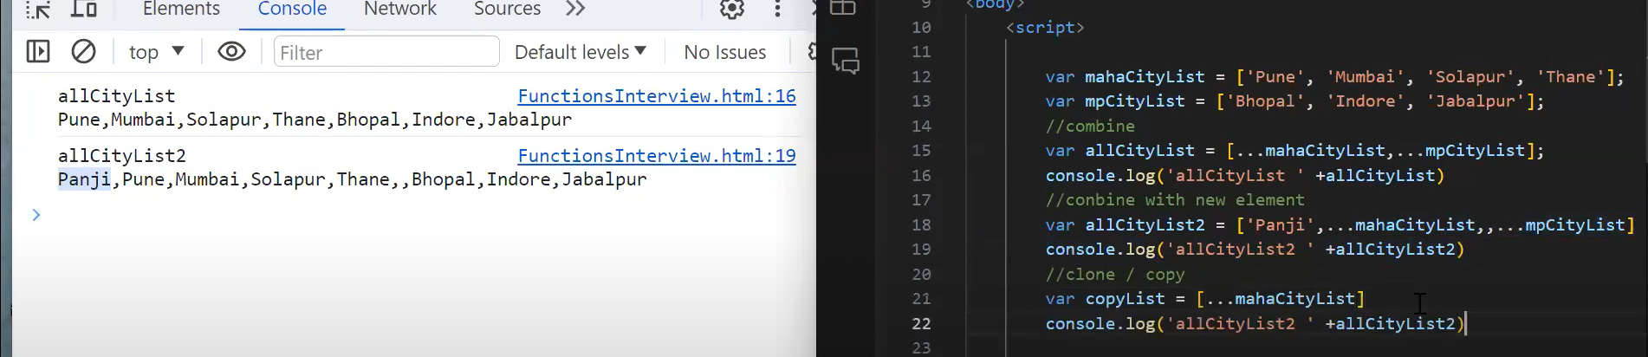

**2.Merging and cloning objects**

**Array er motoi obj eo merging cloning process same**

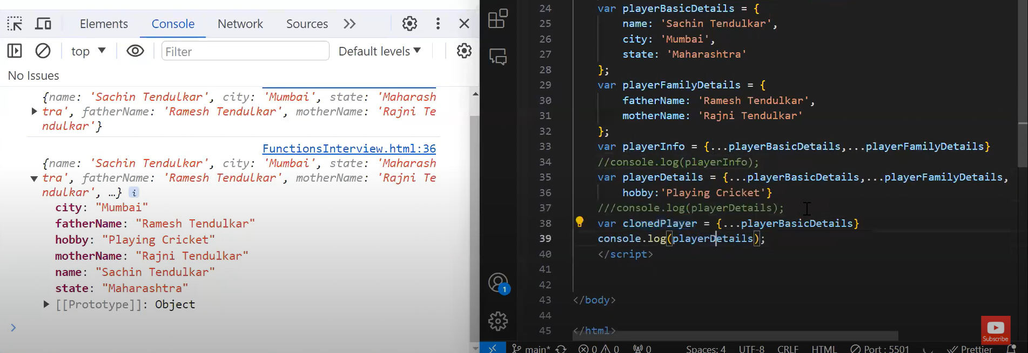

**3.Spreading strings(empty split er alternative)**

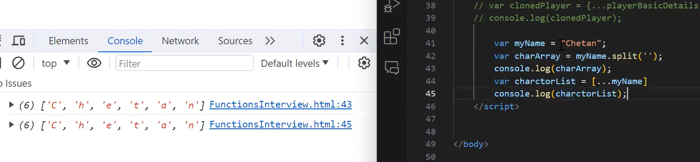

Eita use kore str e thaka number eo max min arithmetic methods use kora jay..karon strong k bhange spread operator

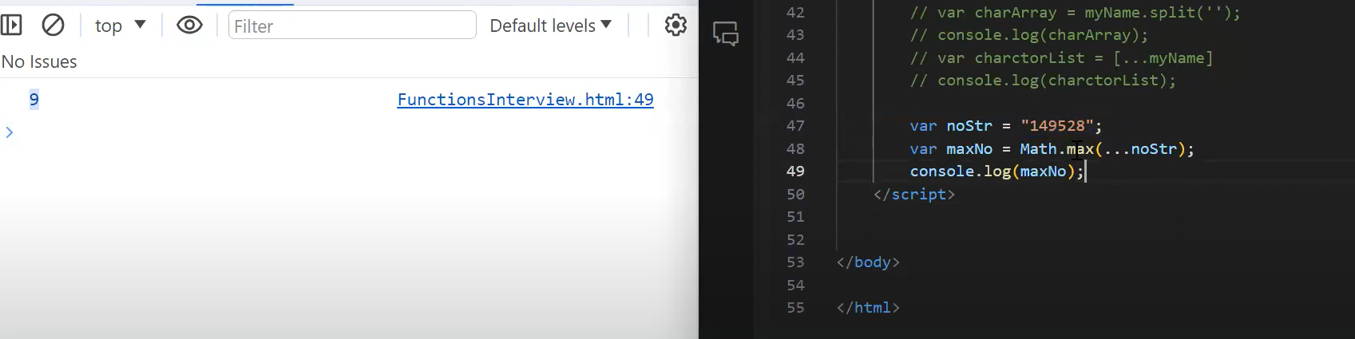

**4.Spreading Function Arguments**

**Func er params k value boshaye print korar 3 ta upay**

**1.var e func name param shoho**

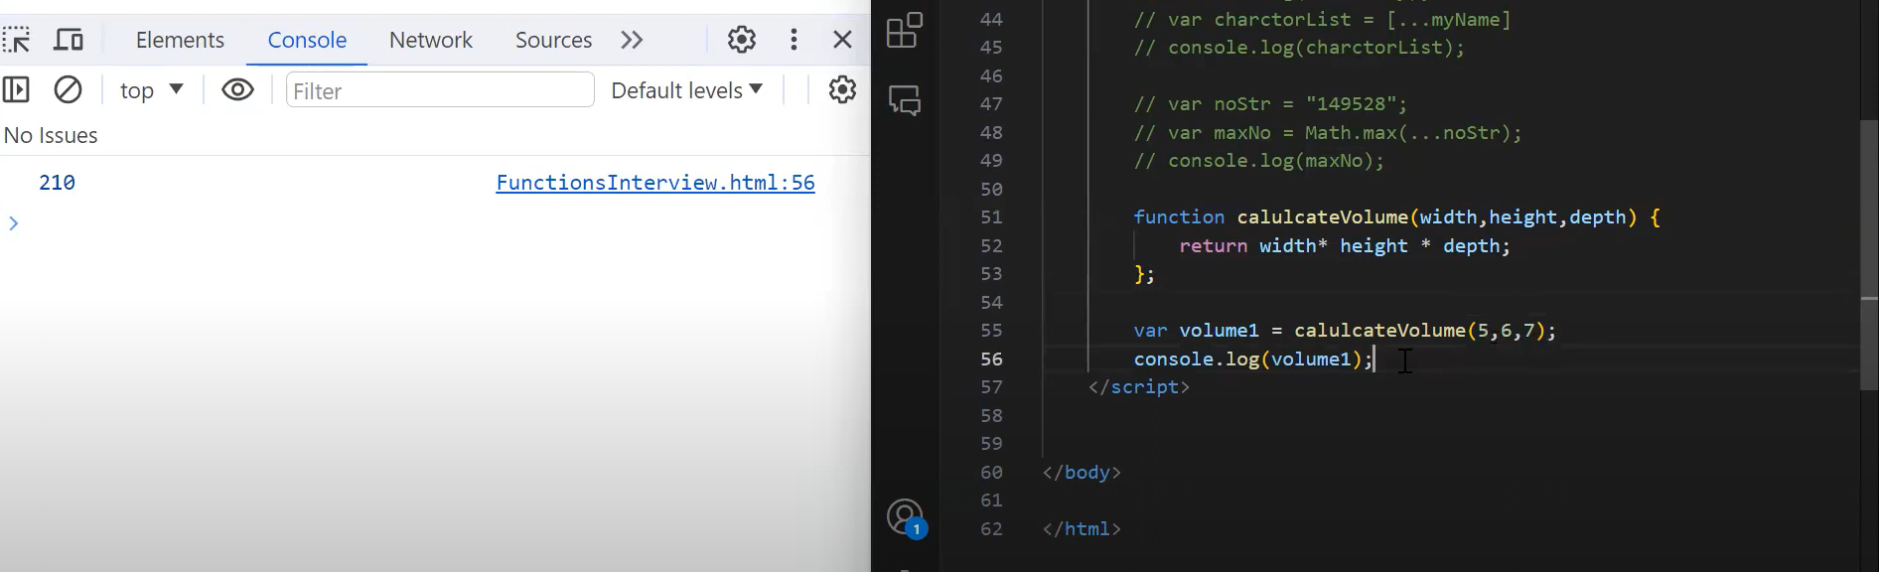

**2.var e array the value boshaye func.apply er maddhome**

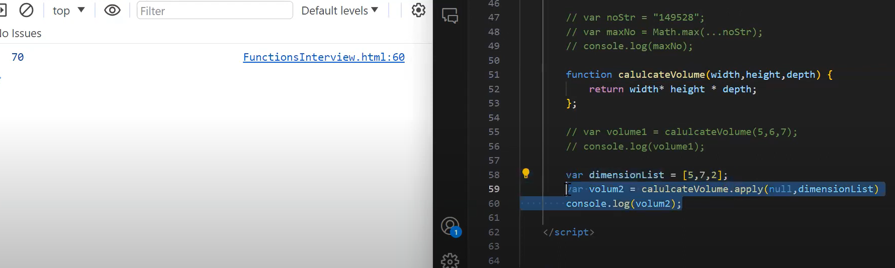

**3.spreaing func arguments**

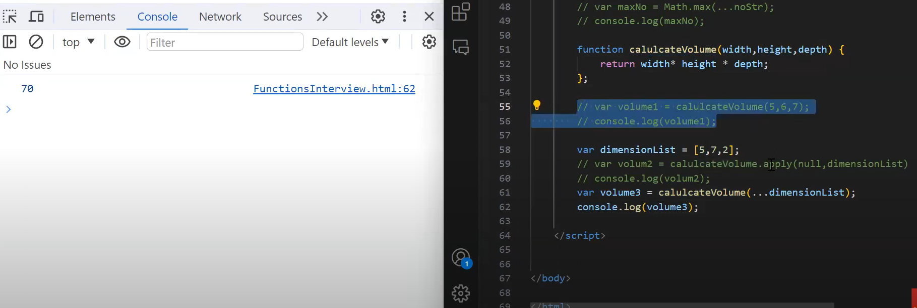

**5.rest parameter => Destructuring**

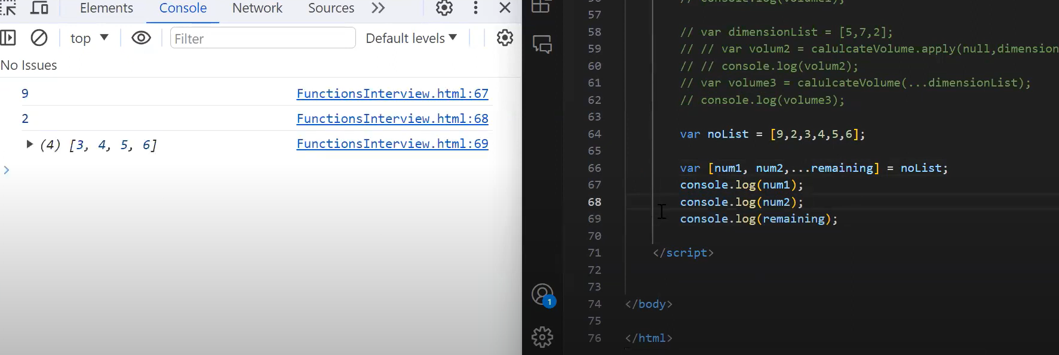

**6.Var,let,constant**

**1.Global r func scope var e**

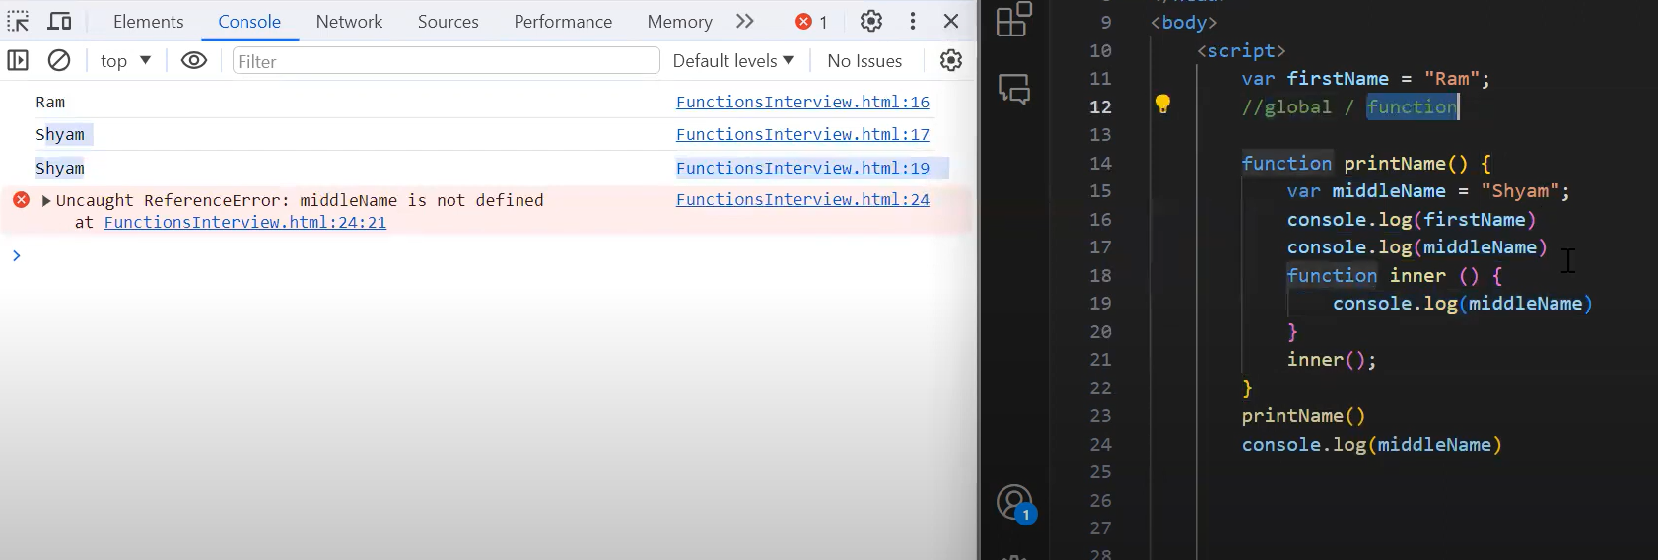

Global howar jonno loop er baireo access kora jay

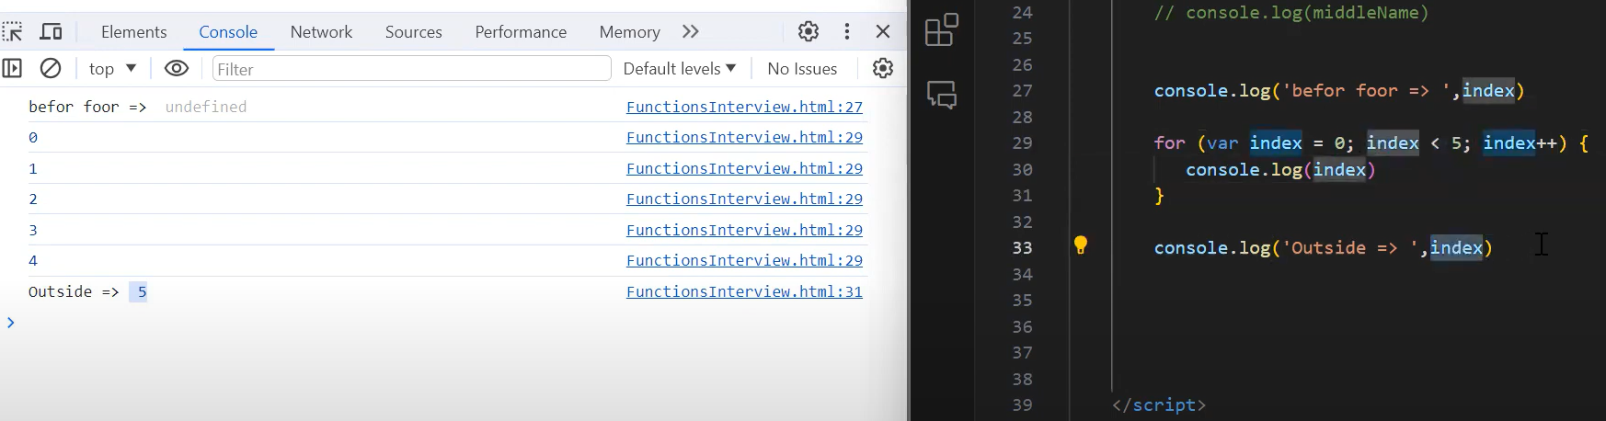

2.Let block scope.loop er baire access kora jayna..

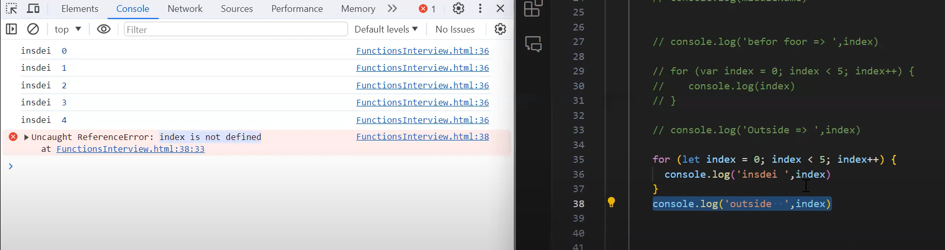

**3.Constant**

**New kore initialized hote parbena…change korte hole object or array e push pop method use kore properties chng kora jabe**

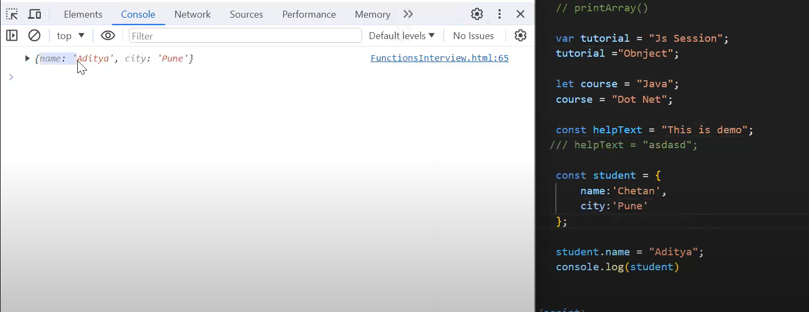

Obj er properties chng kora hoise

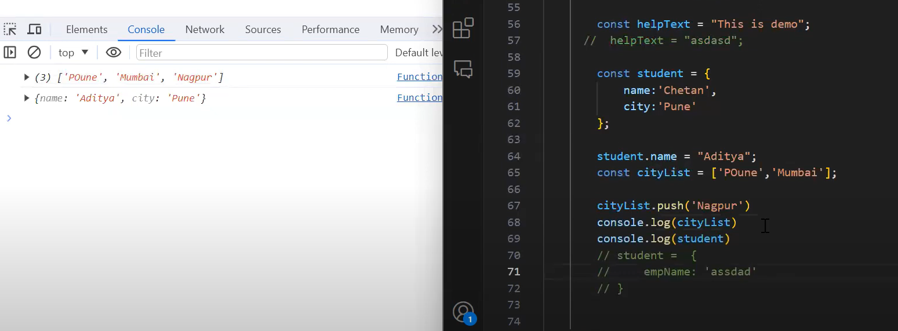

Array the push pop kore chng kora jabe..but var k direct initialize r kora jabena

(one and only var e hoisting er concept kaaje lage)

**7.Array Methods(find,filter,map,reduce)**

Find filter mostly used…shbche kom use hoy reduce

a.Find: just 1 ta value or object return kore..condition match korle jeta shurute ashbe sheta return kore

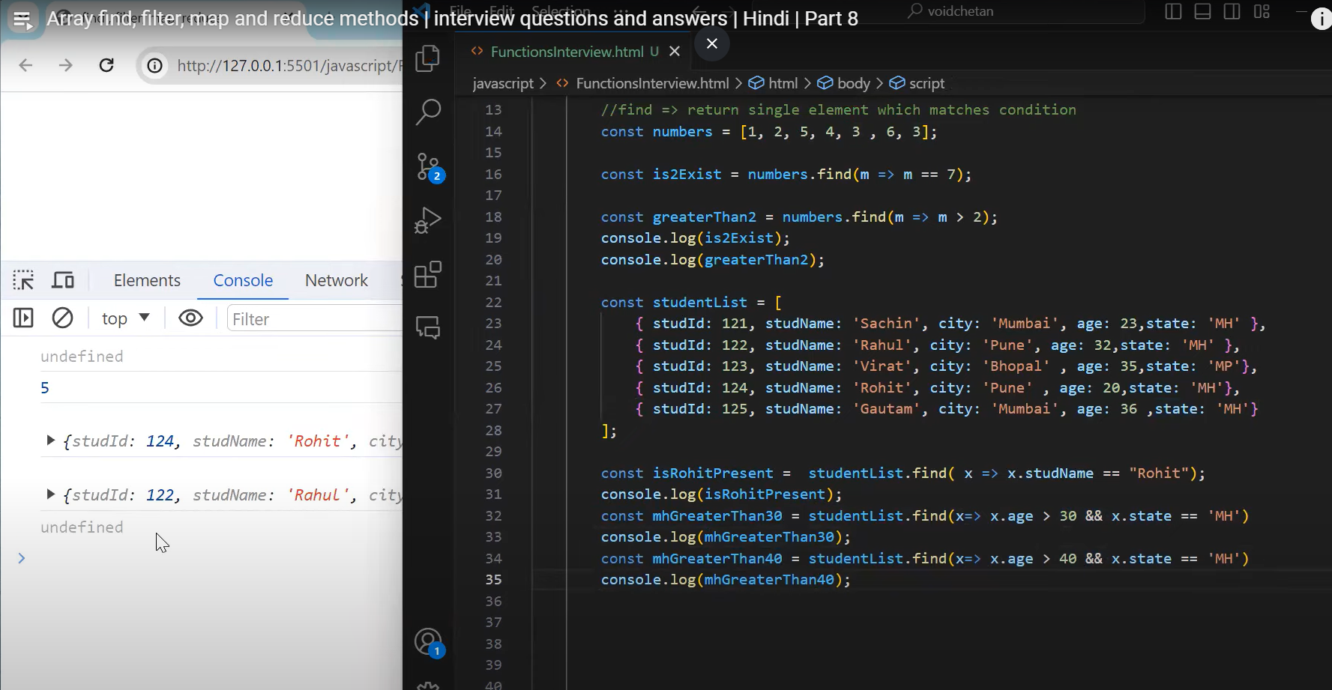

b.filter:filter e multiple value or obj return kore condition onujaye

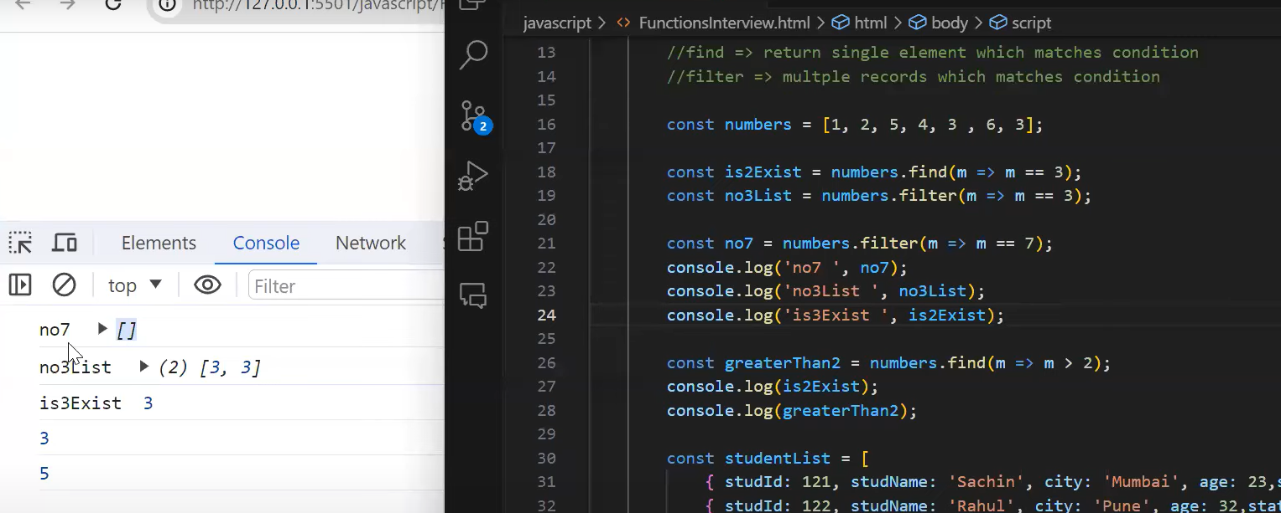

2 ta obj condition match kore tai filter e 2 ta obj return korbe

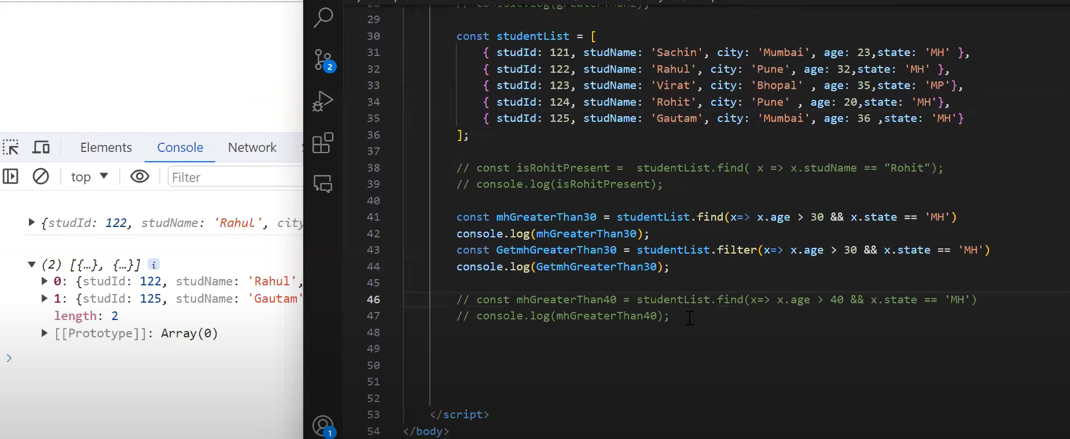

C.map: new array of same length(original array k modify na kore new array create kora kisu chng kore)

Map e 3 parameter

Student,index,originalArry

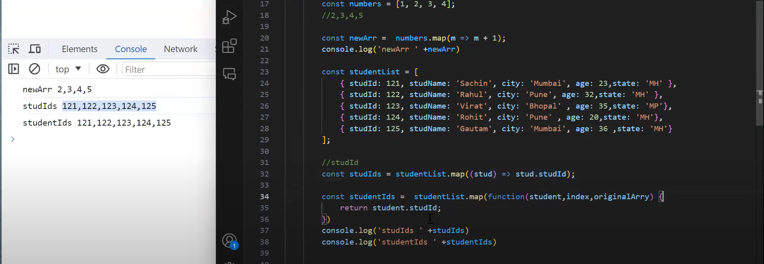

1.number gula k 1 kore baraise

2.arraw func use kore kora easy but basic holo normal func e 3 ta params thake,01st index er individual obj (student,Index=0,total array obj)…For loop akare individual obj gula agate thakbe original array er traverse kora porjonto new array create hobe return onujaye

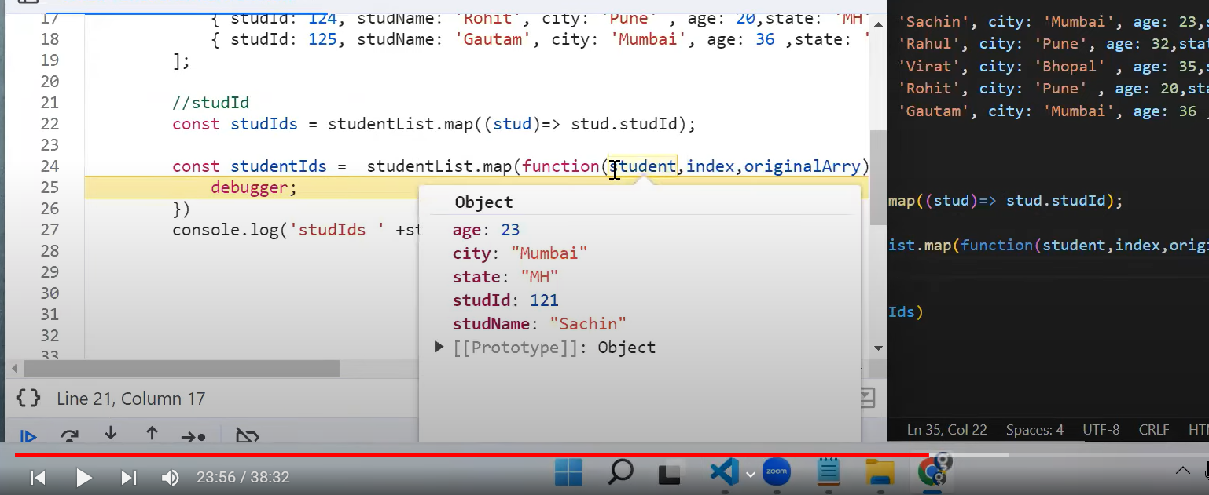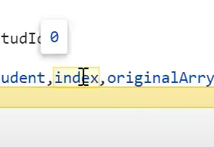

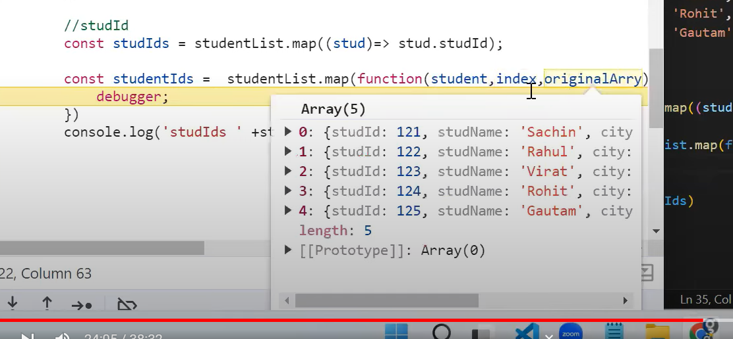

3.new key use kore new array object:

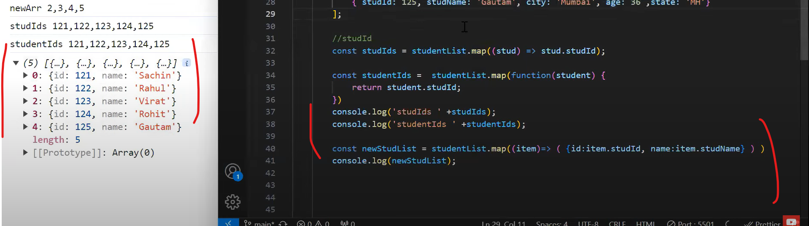

…item use kore ager gula k clone kore new properties add korlam prottek obj e

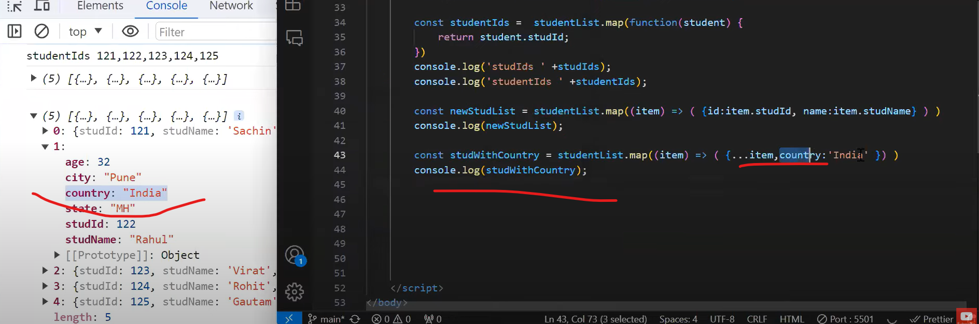

D.Reduce

Number er belay last er initialization params mandatory na but array obj e mandatory

Current,next params use kore sum ber kora…method gula simple loop akare use hoy…

